SAFETY DATA SHEETS
Our electronic SDS solution is VelocityEHS®

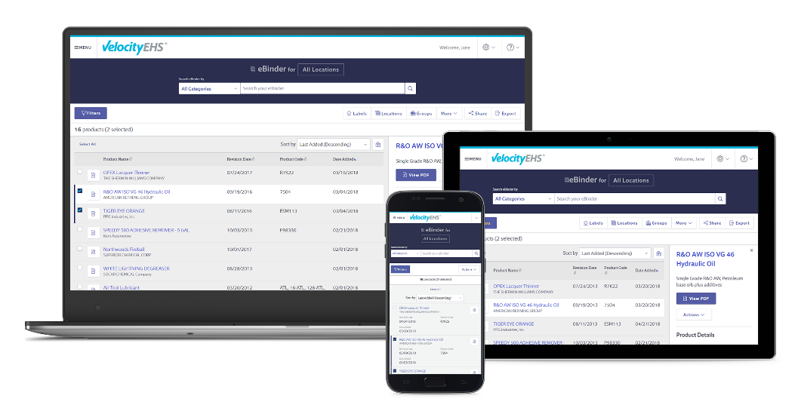

 | For online access to  a safety data sheet,  scan this QR code.

Manual entry: paste Company Link URL here

Find the SDS/Chemical Management app in the App Store and Google Play.

If you need assistance, contact VelocityEHS
222 Merchandise Mart Plaza, Suite 1750 ^{l} Chicago, IL 60654

Toll-Free: 1.888.362.2007
www.msdsonline.com

 | 
INSTRUCTIONS FOR USE:

There are two items you must replace on this poster template for your staff to be able to access your VelocityEHS Chemical Management (MSDSonline) account: the QR code image and the Company Link URL.

Information about how to share your Company Link is available in the “Sharing your Company Link with staff” help article. Use this method to copy and paste the Company Link URL as indicated on this poster template.

The above article also contains information on how to access your Company Link QR code. Perform the steps to create QR Code Labels, then use a screen capture tool (such as the Snipping Tool in Windows) to capture an image of the QR code. You can then replace the sample QR code on this template.

Please note: VelocityEHS does not officially support link shorteners and cannot guarantee functionality if you use one. Always test your links and QR codes before placing your posters for staff access.

