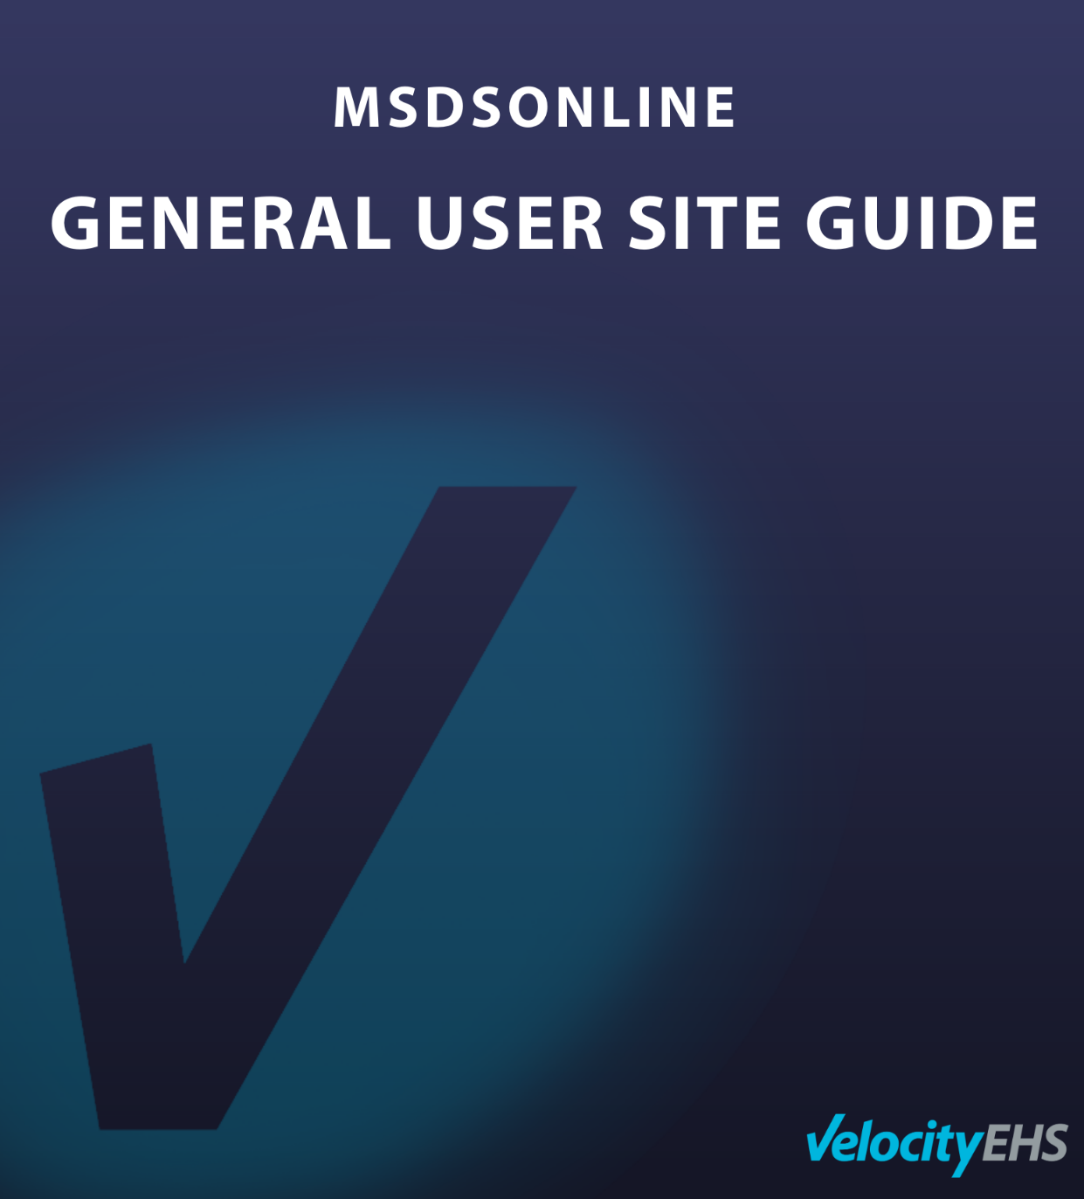

Contents
Accessing Your Account’s General User Site 2
The Company Link 2
The General User Site 2
Edit Preferences 2
eBinder Search 3
Locations 4
Filters 4
Search Suggest 6
Search Results 7
Viewing an (M)SDS 8
Viewing the Product Summary 8
Printing Labels 10
Creating and Printing a Label 11
Sharing the Product URL 13
Viewing Attached Files 13
What to Do When You Can’t Find an (M)SDS in Your eBinder 14
Searching the MSDSonline Database 14
Submitting a Request 16

Accessing Your Account’s General User Site

The Company Link
The Company Link is a URL that grants access to your company's safety data sheets (SDSs) and will be provided by your account’s Administrator so that you can access your account’s General User Site.
When distributed as a URL, it will look like this:
https://chemmanagement.ehs.com/company/XXXXXXXXXXXXXXXX
Highlight this link and then copy and paste it into the address bar of your desktop or mobile browser, or in the Company Link Login Screen in the MSDSonline SDS/Chemical Management mobile application.

The General User Site
The General User Site is the read-only view of your company’s safety data sheets and associated information. All users have access to the General User Site, though the level of access can be adjusted by your administrator. If any details in this guide do not match what you see on your screen, check with your administrator.

Edit Preferences
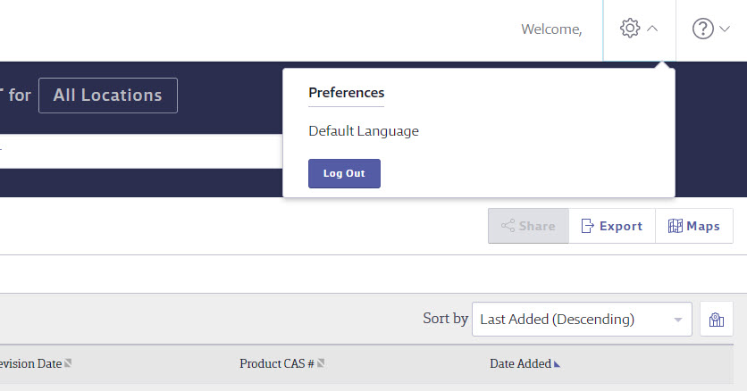
To edit your preferences, click on the gear icon in the top right corner. From there you can set your Default Language.
Setting a Default Language translates all system tools into the chosen language.

eBinder Search
Depending on your account’s settings, you will either enter through the eBinder Search, MSDSonline Search, or the Dashboard. We’ll focus first on the eBinder. If you don’t see the eBinder, click the Menu button in the top left corner and select eBinder.
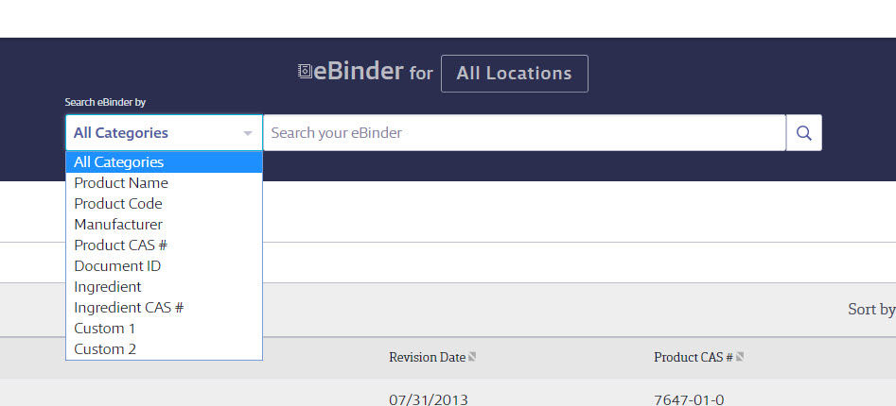

The eBinder gives you advanced tools to search your company list of (M)SDSs.
You can search the eBinder using the dropdown by specific product details including:
- All Categories
- Product Name
- Product Code
- Manufacturer
- Product CAS #
- Document ID
- Ingredients
- Ingredient CAS #
- Custom Fields (i.e. fields that your administrator has created specific to your company, like Stock Numbers or Company IDs)

Locations
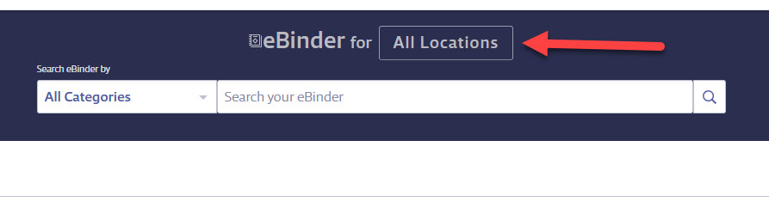
Above the search bar, you will see an All Locations button. By selecting All Locations, you will then have the option to select a specific location to search. Once you have applied a specific location, this will become the default for next time you are searching for as long as you have the site open in your Internet browser. If you close or exit the site it will default back to All Locations.

Filters
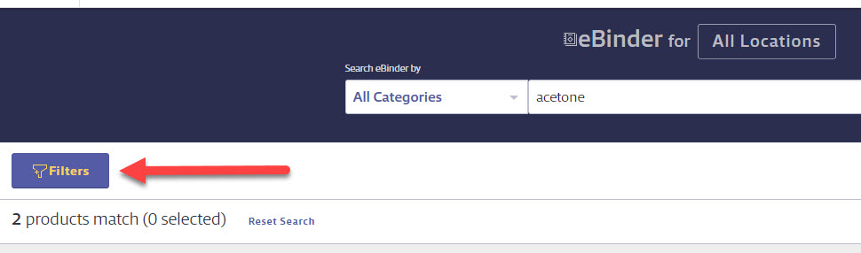
To narrow your search by more specific details, select the Filters button and a modal will appear with additional filter options.
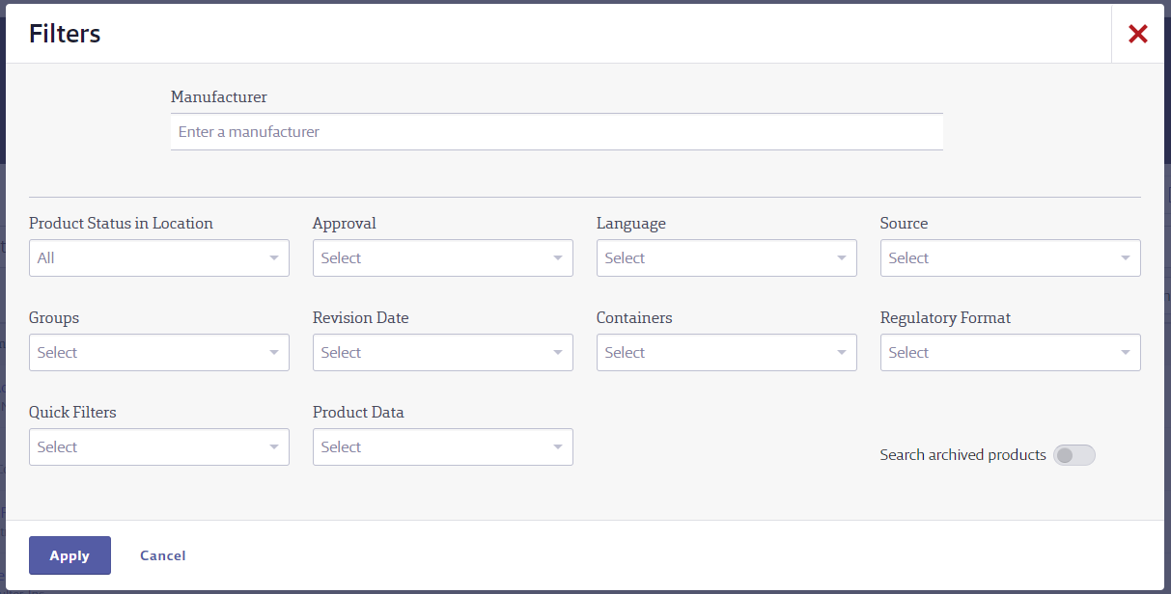

Manufacturer allows you to filter by a specific manufacturer for your searched product.
Product Status in Location allows you to filter products that are not in use or in use.
Groups are setup by your administrator.
Quick Filters allows you to filter by banned, discontinued products, or multiple versions.
Approval allows you to filter by approved, pending, or not approved products.
Revision Date allows you to filter for products with revision dates less than 1 to 5 years.
Product Data is composed of all possible data that could have been indexed from the (M)SDS. The Product Data dropdown may include:
- Custom Module (or the custom name your administrator has given this field) allows you to search by organization specific data that has been added to this area in your account. Ask your administrator for more details, or if they are using the Custom Module.
- DOT Hazard Classes
- First Aid
- GHS Classifications
- Health Hazards
- HMIS Ratings
- Ingredients
- NFPA Ratings
- Physical Hazards
- PPE
- Precautionary Statements
- Regulatory Lists
- Risk Phrases
- Safety Phrases
- Target Organs
- TDG Hazard Classes
- WHMIS Classifications
Language allows you to filter by products in specific languages.
Containers allows you to filter by products with or without containers.
Source allows you to filter products by the source that they were added. The options are:
- Auto Update
- Request
- Upload
- Library Search
- MSDSonline Project
Regulatory Format allows you to filter by the different regulatory formats.

Search Suggest
The single search field is smart enough to know the contents of your company list, and will start to offer suggestions after you type in three characters. This will help you find possible matches for your search terms, and can also solve tricky spelling problems.
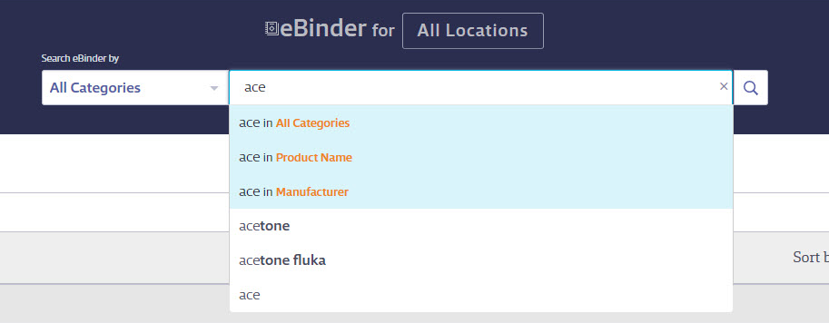
Once you see a Search Suggest that matches your product, choose the suggestion and press Search to process your search.

Search Results
The Search Results screen will appear after you have enacted the eBinder search.
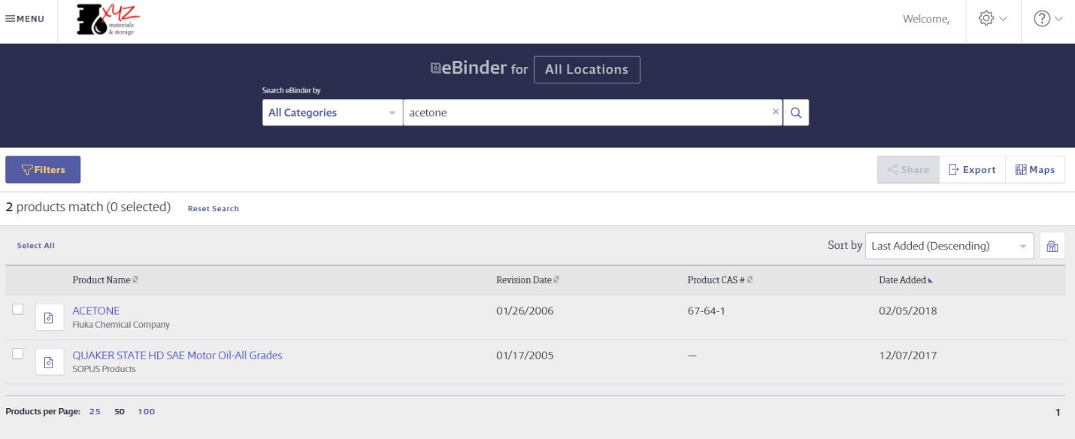
The Search Results screen holds many tools for further filtering and sorting your results.
- By clicking on Select All, this allows you to quickly select all search results. Once clicked, this function will change to Deselect All which you can click to undo selections.
- To quickly sort by the column headers, select the arrow icon () next to the column name. Once selected this icon will be updated to one blue arrow (). By clicking on this icon, it sorts by ascending or descending order.
- The Sort by drop down is another way to filter by selecting from that list. The options in the drop down are based off the columns that you have selected.
- The columns icon (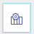) allows you to select up to 3 columns to show besides Product Name (which is a default). Once you click the icon, you will see the list of available columns. The order of which they are listed, is the same order is which they will show on your results page.

 An Export to Excel button is available to download your search results to a spreadsheet for reporting or inventory purposes.
A Container Map icon is available to view your products on maps of your locations.
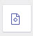The PDF icon next to the Product Name, allows you to open the (M)SDS for the corresponding product. You can also view the PDF by clicking on the Product Card to open the Summary Panel.
The Checkbox icon, when clicked, gives you the options to create and print secondary container labels (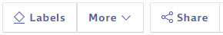 ) and share the product URL (). We will go over both of these functions in more detail later in this user guide.

Viewing an (M)SDS
After selecting the PDF icon for a product, an Adobe window will open displaying the (M)SDS for the product:
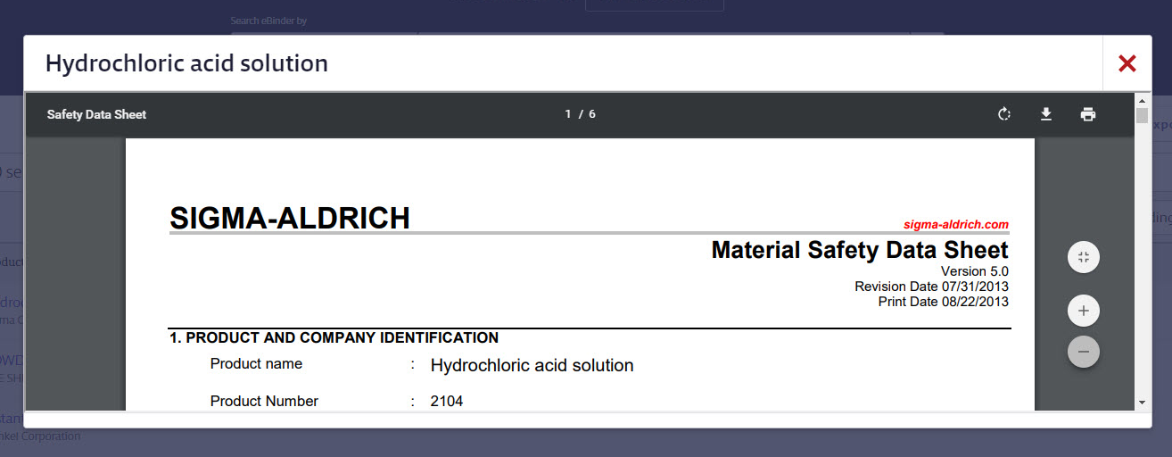
Notice the toolbar over the document – from here you can rotate the document, download/save the document to your computer, and print the document. On the right side of the document is a row of buttons which are your options to zoom in or zoom out of the document. In the upper right hand corner of the PDF window is a red “X” button which closes the (M)SDS.

Viewing the Product Summary
The Product Summary is a display of all information that has been indexed within the your account for that particular (M)SDS. You have two options to view this information, a high level overview (Summary Panel) and a more detailed Product Summary.
To access the high level overview Summary Panel (b), click on the Product Row (a).
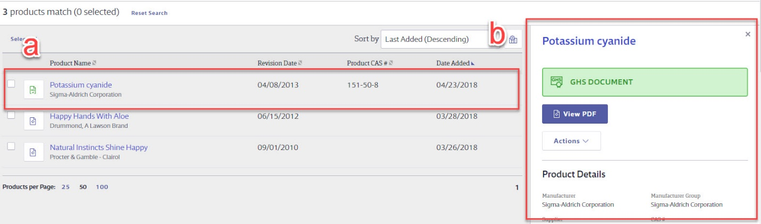
From the Summary Panel, you will see the following options/information:
- View PDF
- Actions
  - Print Labels
  - Share
- Product Details
- Product Inventory
- SDS Information
- Go to Product Summary
Another way to access the detailed Product Summary is to click on the Product Name.
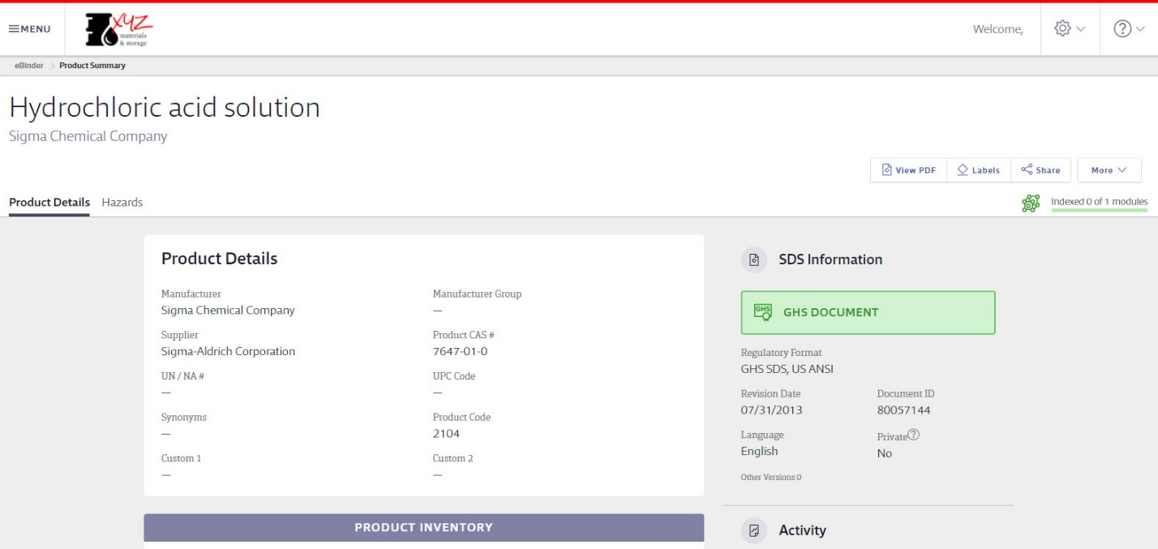
You will see functions available in the Product Summary that are similar to those found in Search Results:
- View the PDF
- View Attached Files
- Print Labels
- Share Product URL
- Print Summary Sheet: allows you to print a copy of all the summary details for an (M)SDS
Additionally, users have the ability to scroll through modules detailing information about the product, from the locations where that product is assigned to the ingredients that make up the product.

Printing Labels
Secondary Container Labels, or Workplace Labels, are critical to any Hazard Communication plan. When companies know they use a large amount of a chemical, they will often buy that chemical in bulk and then transfer it to smaller containers. MSDSonline helps facilitate creating labels for those new containers.
After selecting Print Labels, you will arrive at the Print Labels page:
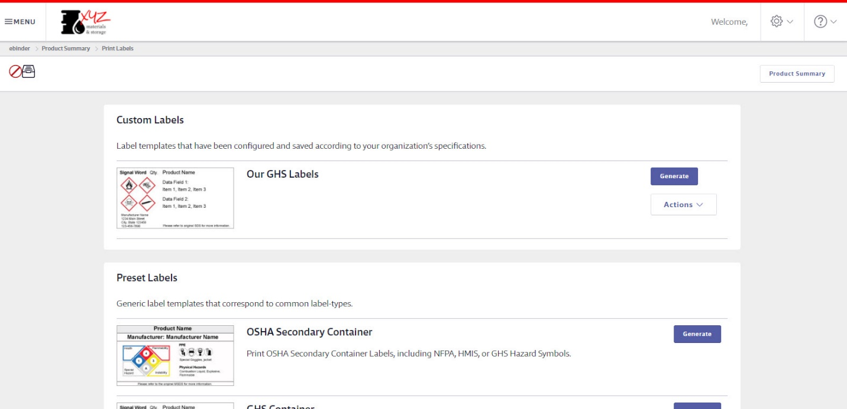

There are three categories of label templates that can be generated:
- Custom Labels
  - Labels created by the Administrators
- Preset Labels
  - Generic label templates
- Vendor Labels
  - Templates that integrate with label-making devices

Creating and Printing a Label
Selecting the label template you require will bring you to the wizard for generating your label.
Label templates created by your administrator for your organization will only require you to generate the label.
For MSDSonline-created label templates, there will be multiple steps involved in order to create your label.
There are four steps to creating and printing most MSDSonline labels:
- Choose your Label Size: make sure you know the size of your container before printing!
- Choose your Hazard Symbol: hazard symbols appear on every label, and where multiple hazard symbols exist, they may need to be reordered in terms of priority.
- Choose your Data Fields: the data fields are those important details you feel need to be included on the label. The number of allowed data fields will vary depending on the size of your label.
- Choose your Print Options: Decide whether to print a single label or a full sheet of labels.
Upon selecting the Generate Label button, a new window will open with your Label preview. Notice the Adobe toolbar contained in the top of the window frame. From here you can rotate the document, download, and/or print your label(s).
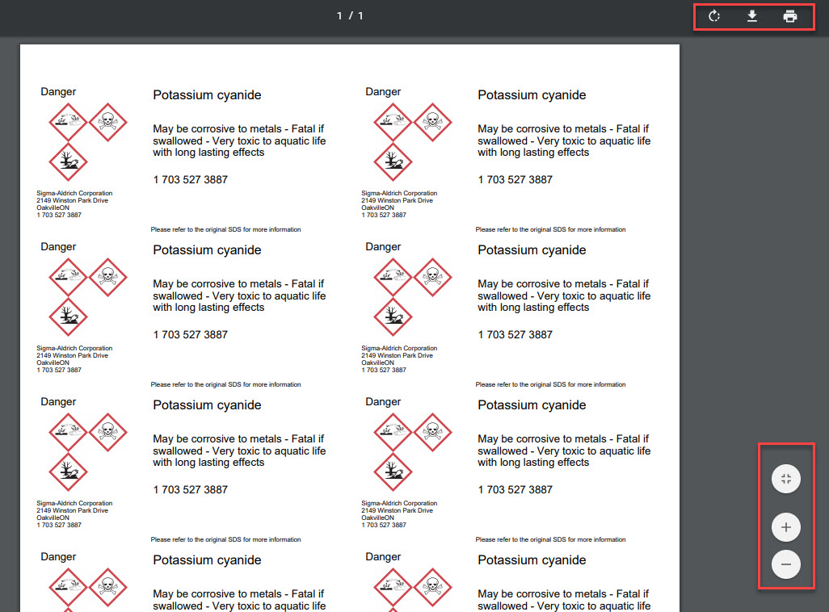

Sharing the Product URL
Once you have selected the product via the checkbox, a Share button () will become available for you to share the product URL. You will have the option to either copy/paste the product URL or select the Email button to open up an email directly with the link.
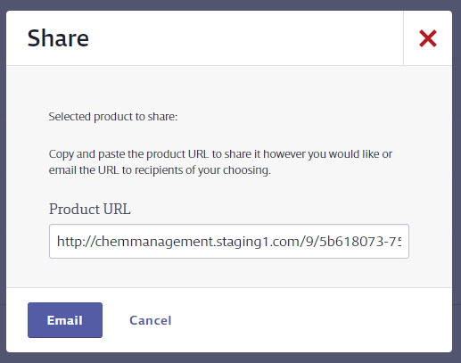

Viewing Attached Files

Attached Files allow administrators to provide further guidance on the safe handling of a material. After selecting the Attached Files icon, you’ll be taken to the Attached Files page:
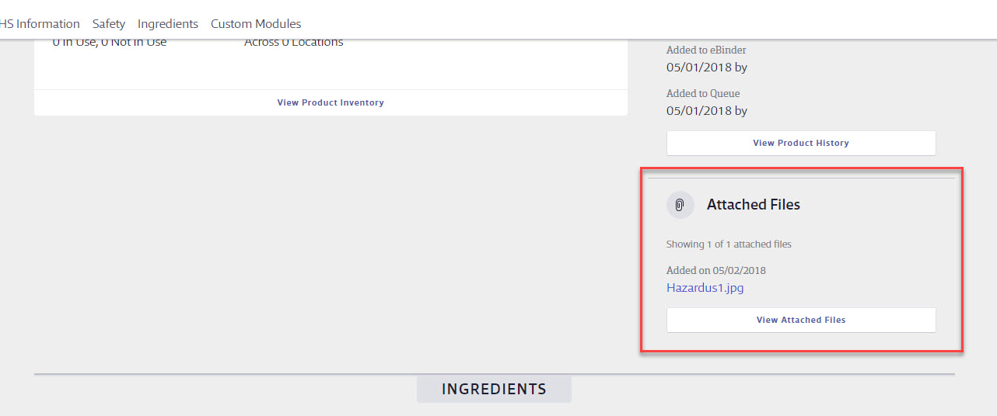
Here you can view any files that have been appended to this (M)SDS – just select the file name. Attached files can also be sorted by selecting any of the column headings.

What to Do When You Can’t Find an (M)SDS in Your eBinder

Searching the MSDSonline Database

If you perform a search within your company’s eBinder and come up with zero results, one of your options will be to look at matches found in the MSDSonline database. Additionally, you can select the MSDSonline Search in the Menu to jump directly to searching the MSDSonline database.

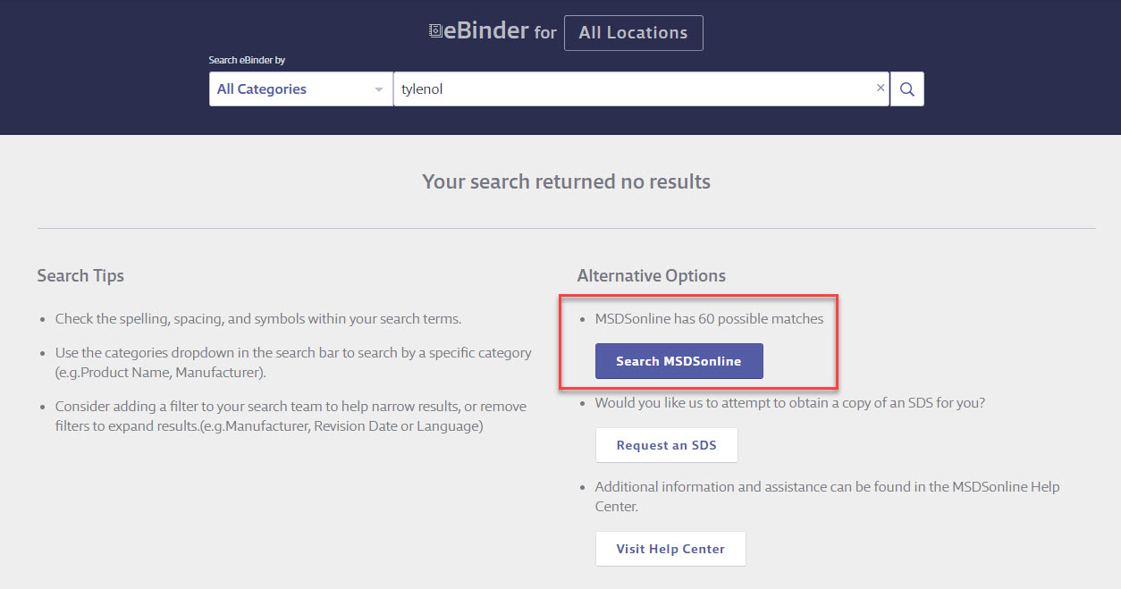

In the example above, there are 60 possible matches in the MSDSonline database for a search that returned zero results. By selecting that option, you’ll be brought to the MSDSonline database with your 60 options displayed:
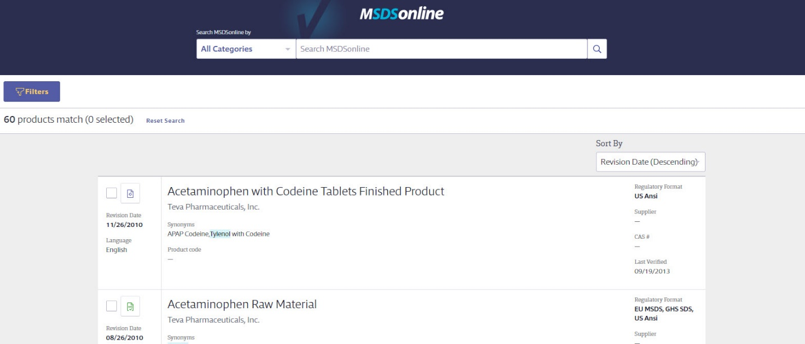
From here, the same rules for search features apply as in searching your company’s eBinder. The only difference is that from the MSDSonline database you may have the ability to add the (M)SDS you need to your eBinder:
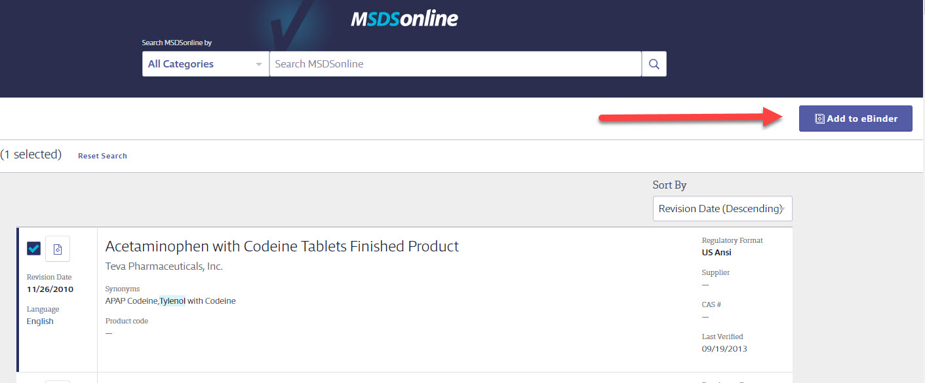
After selecting the checkbox, use the Add to eBinder button to add this product to your company’s account.
Be aware that some documents may require approval from your administrator prior to being added to your eBinder. You may have to fill out an approval form with details for your administrator:
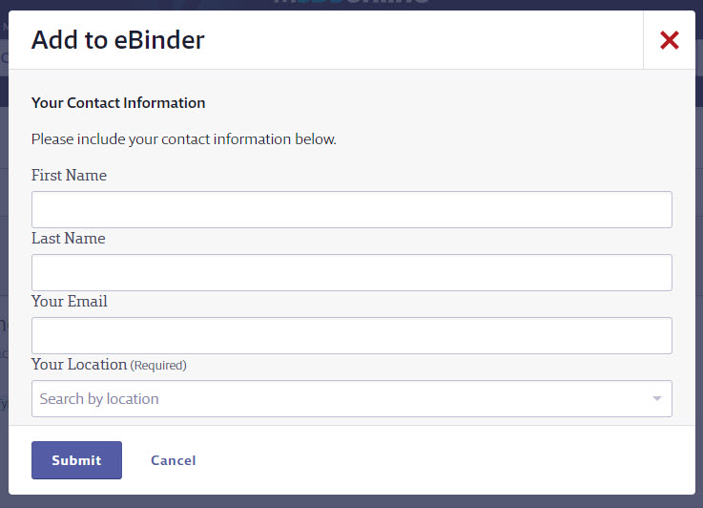
Simply fill out the form and select Submit.

Submitting a Request
Sometimes you may encounter a search where the document you need cannot be found in either your eBinder or the MSDSonline database. In a case like this, simply select the Request a Safety Data Sheet option when you receive zero results:
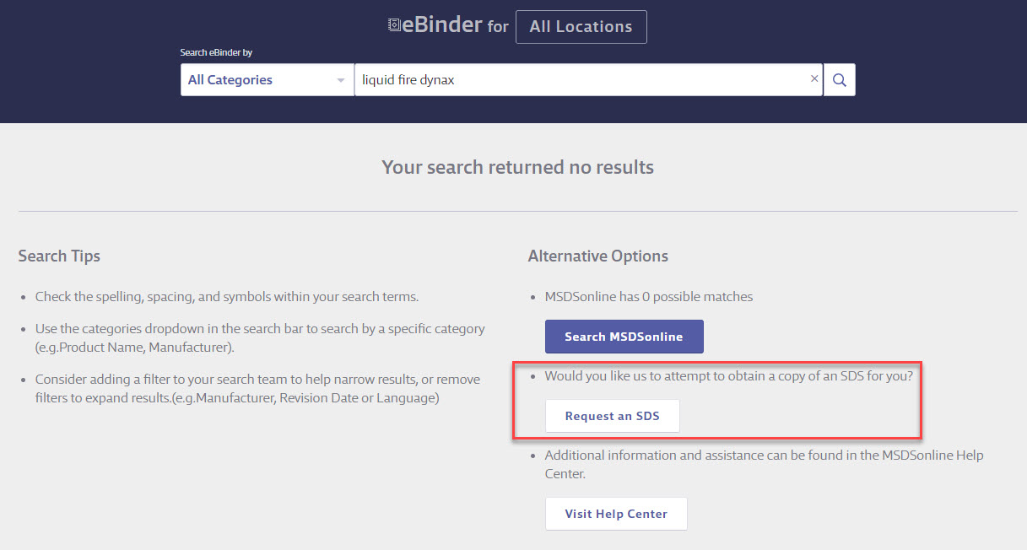
Depending on the settings of your account, your request will either be transferred to your administrator or direct to MSDSonline.

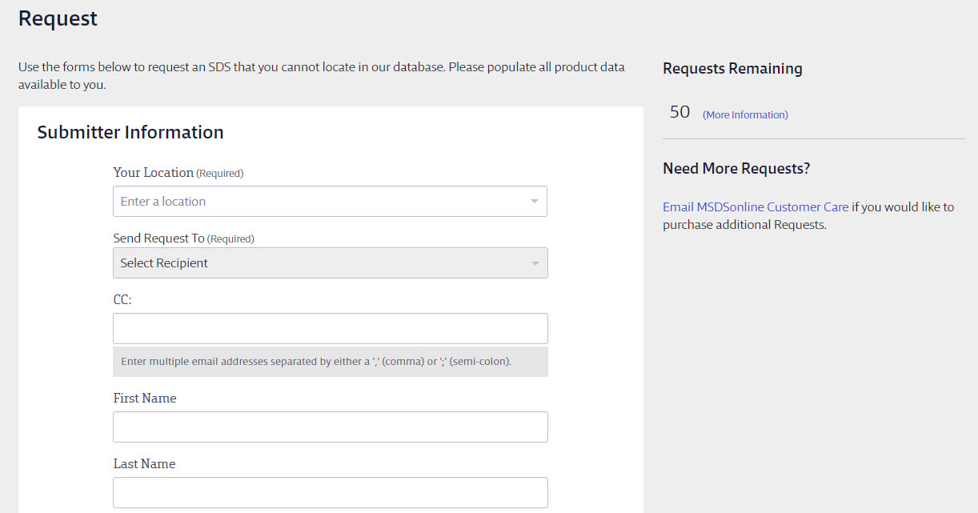
To request an (M)SDS, simply fill out the form with as much detail as possible. This will help your administrator or MSDSonline find and add the (M)SDS you need.

Definitions: Users = any employee using the MSDSonline HQ Account vs. General Users = any employee currently accessing the General User Site.
Note: MSDS details, such as Product Name and other indexed data, will not be translated. Additionally, MSDSs will remain in the language set by the manufacturer.

