General User Quick Start Guide to Using MSDSonline

Accessing your Account

Go to your Company Link: https://chemmanagement.ehs.com/{enter_link_here}.

Please highlight this link, then copy and paste it into your browser’s address bar. If you need help locating your Company Link contact your account’s administrator.

Accessing the eBinder

If your account does not default to your eBinder, click on the Menu button in the upper left corner of the screen and then click on the eBinder button.

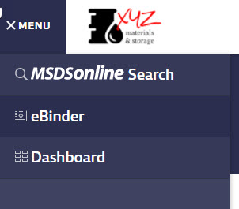

Searching for an (M)SDS within your eBinder

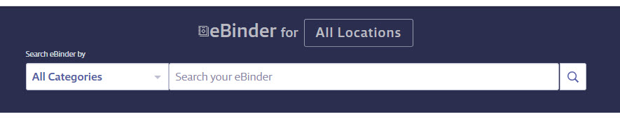

- Type the product information into the single search field and click Search.

Hint: After you type at least three characters of your search term into the Search Bar, you will see suggested search results and categories. You can either click on one of these options, click the Search button, or press Enter on your keyboard.

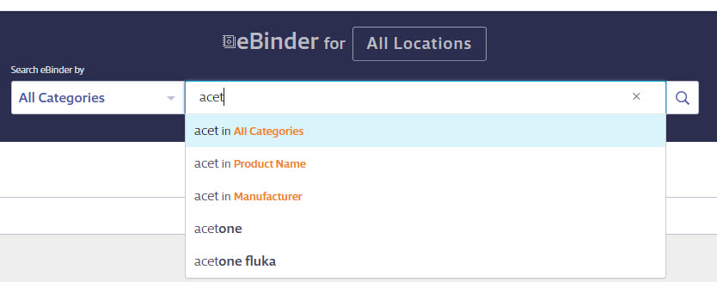

- You can also use the Categories menu drop down to pre-filter your search results. By default, the eBinder will search by “All Categories”. If you want to search in only one specific category, click on the Categories menu drop down and select the category. After that has been selected, you can then proceed to type your search term into the Search Bar and click the Search button.

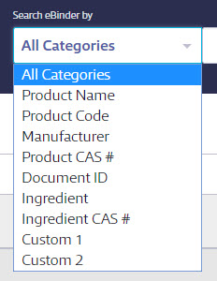

- If searching your eBinder produces no results, you will have the options to either “Search MSDSonline” or “Request an SDS”. Note that these options will only be available if enabled in your account.

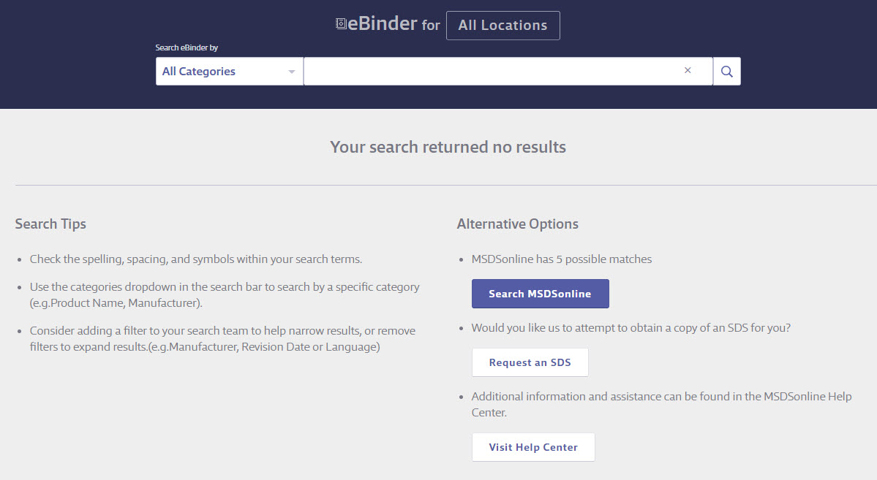

Viewing and Printing Safety Data Sheets

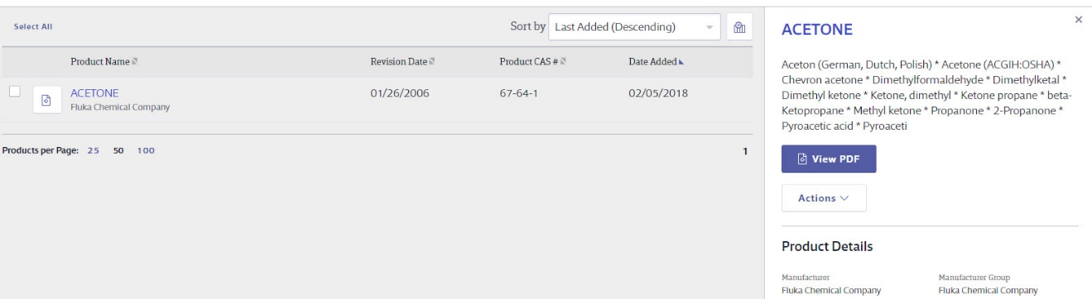

- View the (M)SDS by clicking the Document icon to the left of the Product Name. Once open you will see options in the top right corner to rotate the document clockwise, download, or print the (M)SDS.

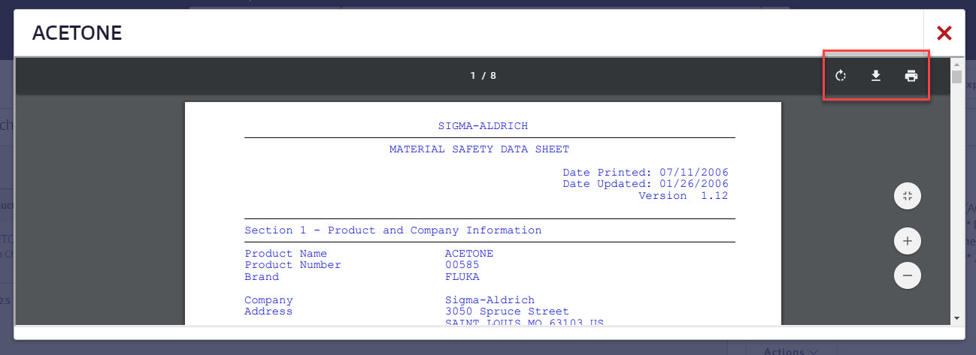

- Clicking on the Product Name will take you to the Product Summary. From here you will see the Product Details and any indexed data.

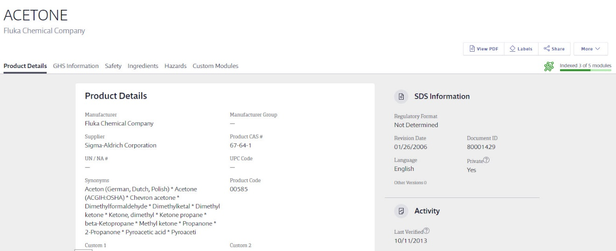

- Print labels for secondary containers by selecting the Labels button next to the View PDF button.
- a) Choose your label
- b) Select the data fields you would like to include on your label
- c) Select “Generate Label”

