General User Guide to Using the Company Link

The Company Link

The Company Link is a URL that grants access to your company's safety data sheets (SDSs).

The Company Link is also known as your organization’s HQ link, or the General User Site URL.

When distributed as a URL, it will look like this:

https://chemmanagement.ehs.com/company/XXXXXXXXXXXXXXXX

Highlight this link and then copy and paste it into the address bar of your desktop or mobile browser, or in the Company Link Login Screen in the MSDSonline SDS/Chemical Management mobile application.

When distributed as a QR code, it will look like this:

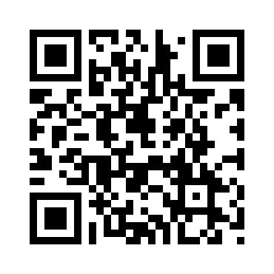
This QR code is the URL for the Wikipedia page about QR Codes

Scan the QR code using a mobile device with a barcode scanner installed.

Locating your Company Link

The Company Link is typically found on your company's intranet website, or as a shortcut on a computer workstation.

Sometimes, a QR code of the Company Link may be printed off and attached to a poster or sticker.

In some instances, it may be emailed to you by your primary MSDSonline Account Administrator.

If you have trouble locating your Company Link, contact your Administrator.

Using the Company Link to log into the SDS/Chemical Management Mobile App

NOTE: These instructions assume that you have the SDS/Chemical Management mobile app installed on your device.

- If the Company Link was emailed to you, open the email on your mobile device.
  - Copy the Company Link
  - On the main login screen of the SDS/Chemical Management mobile app, tap the DON’T HAVE USERNAME OR PASSWORD? button
  - On the Company Link Login screen, paste the link into the Company Link field
  - Tap the Log In button

  - If you are unable to copy and paste the Company Link from an email on your mobile device, type the link into the Company Link field.

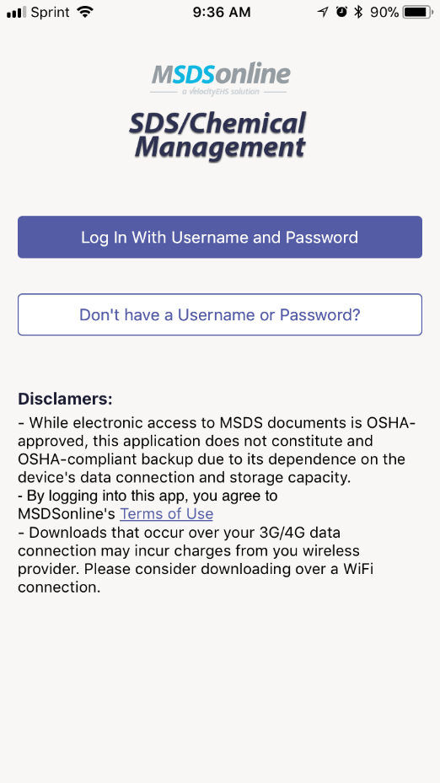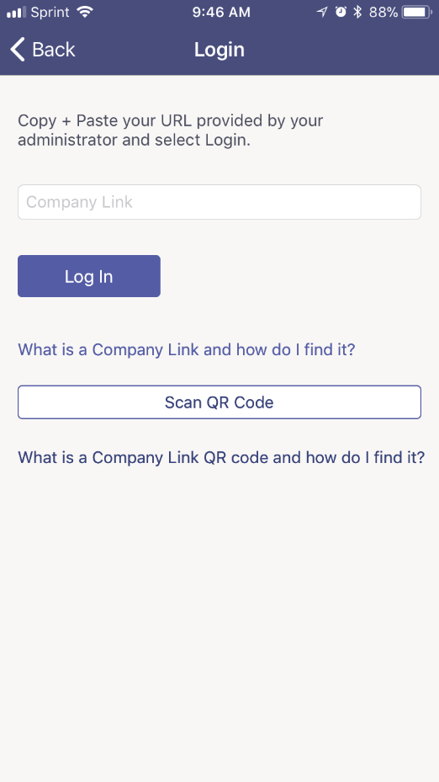

If your Company Link was distributed as a QR code, tap the Scan QR code button to use the camera on your mobile device to scan the QR code and log into your eBinder.

Getting the MSDSonline SDS/Chemical Management Mobile App

The SDS/Chemical Management mobile app will let you sync your mobile device to your MSDSonline account, giving you instant access to your safety data sheets and product details whether you’re on-site or in the field.

While your device is connected to the internet, search and view products to get the information you need.

Save products to your device and their details and safety data sheets will be at the ready when your device is offline.

The SDS/Chemical Management mobile app makes it easy for you to stay informed about the products in use throughout your company.

With eBinder, product and inventory information—and the actual safety data sheet—are just a few taps away, and available both online AND offline.

You can download the SDS/Chemical Management mobile app from the App Store and Google Play.




Using the Company Link to access your company’s eBinder with a mobile device browser

NOTE: If you don’t have the SDS/Chemical Management mobile app installed, you can still access your company’s eBinder with a web browser, such as Google Chrome or Apple Safari. The MSDSonline website, where your company’s eBinder lives, works on all mobile operating systems.

- If the Company Link was emailed to you, open the email on your mobile device.
- Tap on the link to view the MSDSonline website in the browser installed on your device or open the browser on your device and copy and paste the link into the address bar.

- If you are unable tap to open the link or unable to copy and paste the Company Link from an email on your mobile device, type the link into the address bar of the web browser on your device

- Once you have used the Company Link to access your company’s eBinder in this way, you can bookmark it for future use.

